Target monitoring evaluation

Introduction
Target monitoring evaluation (TME) (Dunsmuir, Brown, Iyadurai, & Monsen, 2009; Monsen, Brown, Akthar, & Khan, 2009) is a simple model for evaluating progress. While it relies on subjective judgement, it has value in ensuring both that a review takes place and in prompting the reviewers to consider the factors that have led to the progress (or lack of progress) achieved.

Procedure
- The SENCo should agree targets with others involved in the casework. These will arise from collaborative work with the child or young person (CYP), family and school staff. Each target area should be SMART: Specific, Measurable, Achievable, Realistic and Time-limited.
- The baseline level (current level of achievement) should be clearly defined.
- This is given a numerical rating along a Likert scale ranging from 1 to 10 and the letter B for baseline is marked on the scale.
- A date is set for review, and a clear descriptor is made of the level expected for this date. A numerical rating along the Likert scale is assigned to this descriptor. The letter E for expected is marked on the scale.
- At review, another clear descriptor of current behaviour is recorded and this time given a numerical descriptor, labelled A for achieved.
- The completed TME form should be used during termly planning meetings.

Caution
It is not necessarily the case that “greater than expected” progress is better than “expected”, due to the subjectivity of “expected” progress and the many factors that influence overall progress. The key purpose of the review is to prompt reflection on factors leading to or restricting progress to success, and to celebrate with those involved where progress has been shown.

Target monitoring evaluation form
Child/young person name

Present at target setting meeting
Date of
target setting meeting

Name |  |  | Role

Target 1
Rating: | 1 | 2 | 3 | 4 | 5 | 6 | 7 | 8 | 9 | 10
Descriptor of baseline level:
Descriptor of level achieved:

Target 2
Rating: | 1 | 2 | 3 | 4 | 5 | 6 | 7 | 8 | 9 | 10
Descriptor of baseline level:
Descriptor of level achieved:
Target 3
Rating: | 1 | 2 | 3 | 4 | 5 | 6 | 7 | 8 | 9 | 10
Descriptor of baseline level:
Descriptor of level achieved:

Present at target review meeting
Date of
target review meeting

Name |  |  | Role

Samples of completed TMEs

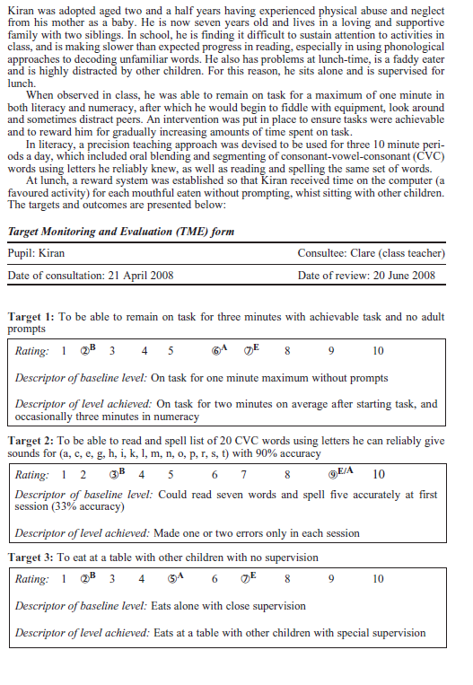
(Dunsmuir et al., 2009, p. 70)

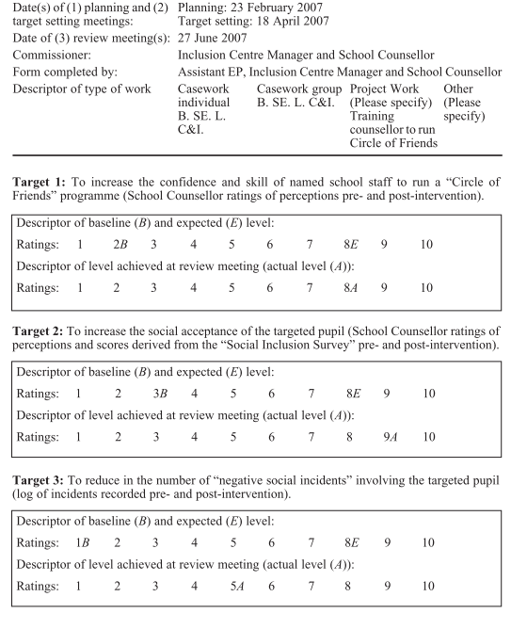
(Monsen et al., 2009, p.383)

References
Dunsmuir, S., Brown, E., Iyadurai, S., & Monsen, J. (2009). Evidence-based practice and evaluation: from insight to impact. Educational Psychology in Practice, 25(1), 53–70. doi:10.1080/02667360802697605
Monsen, J. J., Brown, E., Akthar, Z., & Khan, S. Y. (2009). An evaluation of a pre-training assistant educational psychologist programme. Educational Psychology in Practice, 25(4), 369–383. doi:10.1080/02667360903315180

The literature does not provide any clear guidance about the poles of this scale. However, the scale is intended to provide a prima facie guide to whether or not progress has been below, at or above expectation. For this reason, the baseline level is usually rated towards, but not right at, the lower end of the scale, perhaps at 2 or 3.
Again, because of the lack of pole descriptors, it is difficult to be clear about the number. Clearly, if the intervention is a long one, greater progress might be expected along the scale. Further, the scale should be anchored to allow it to recognise greater than expected progress. For this reason, expected ratings are typically given numbers of about 6 to 8.

